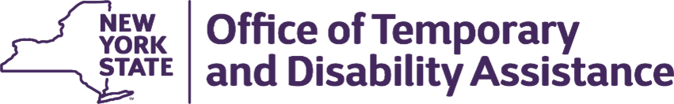
Kathy Hochul
Governor
Barbara C. Guinn
Commissioner
RAJNI CHAWLA
Executive Deputy Commissioner

WMS – CNS Coordinator Guidance

Section 1
Guidance Topic: Release 25.2 – Explanation of WMS/CNS Enhancements Effective June 22, 2025
To: Subscribers
Date: June 23, 2025
Issuing Division/Office: Upstate Systems Bureau (USB)
Employment and Income Support Programs (EISP)
Effective Date: June 22, 2025
Suggested Distribution: Commissioners, TA and SNAP Directors, HEAP Coordinators, WMS Coordinators and BICS Coordinators
Contact Information: Sections 1 – 4: otda.sm.eisp_upstatesystems@otda.ny.gov Sections 5 – 7: DOH Local District Support Unit (518) 473 - 6397

Section 2 – Purpose
The purpose of this guidance is to provide local social services districts (districts) with an explanation of the WMS/CNS enhancements that became operational on the Production System on June 22, 2025, unless otherwise noted.

Section 3 –Vital Records and SSA Auto – Close Process
The monthly auto-close process will be changing for single-individual TA, FS, HEAP and MA cases that are identified from a monthly match performed by comparing the Vital Records Death Match file against WMS. The Vital Records match will be used as the primary source for case closing. The SSA match will be used as a secondary source for case closing.

For this auto-close process, a single individual case is identified where there is only one active person (Individual Status 07) on the case. The Vital Records or SSA monthly auto-close process will occur approximately on the 2nd week of each month.

Case Selection:

SSN, DOB and Sex on file from Vital Records as the primary source or SSA as the secondary source must match those elements on WMS

Case Status: Active, Active Override
Single-individual cases with an Individual Status: Active
Case Type: 11, 12, 16, 17, 20, 21, 22, 31, 60.

Case Processing

Screen 1

Authorization Number = 9, District Code, X, MMYY (Transaction Month/Year)
Transaction Type = 07
Reason Code = I92
Reason Code: H95 for Case Type 60
Notice Indicator = “T”
Authorization TO Date: last day of Transaction Month/Year
PA/FS Indicator for TA Cases: change from 01-Authorized for PA/FS to 08-Closed
PA/FS Reason Code: If The PA/FS Indicator equals 02, 03, 04, 09, the PA/FS Reason Code will be set to 943-Not in Receipt of FS.

Screen 3

PA/MA Individual Reason Code: E95 for all Case Types, with the exception of Case Type 60
FS Individual Reason Code (if in receipt of SNAP): E95

Screen 5

Individual Status: 13
PA/MA Effective Date: Vital Records/SSA match date
FS Effective Date: Vital Records/SSA match date
Individual Status-13 Deceased, will not be generated until the clockdown date has been reached.
MA Coverage To Date will be set to the Transaction Date plus 10 days.

Screen 6/9

Payment To Date: last day of Transaction Month

If the Payment Period From Date is greater than the Transaction Month, any future payment line(s) will be cancelled.

Reports

Eligible Report WINR0789

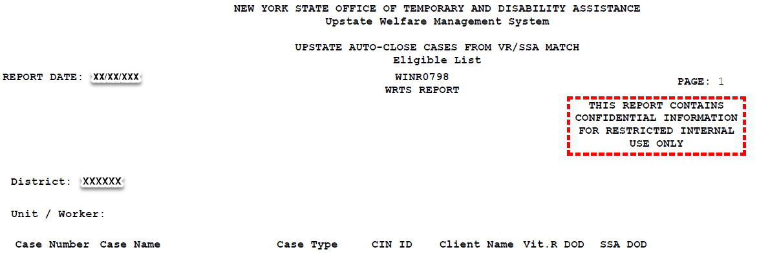

The Eligible report is sent through PHRED in PDF and .csv format, and will contain the following data elements:

Case Number, Case Name, Case Type, CIN ID, Client Name, Vit. R DOD and SSA DOD.

Exception Report WINR0799

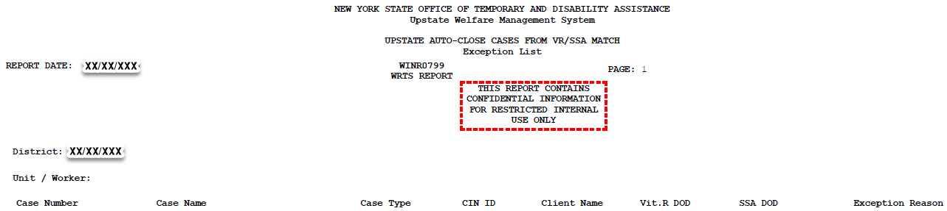

The Exception Report is sent through PHRED in PDF and .csv format, and will contain the following data elements:

Case Number, Case Name, Case Type, CIN ID, Client Name, Vit. R DOD, SSA DOD and Exception Reason.

Exception Reasons:

Pending Status
Clock Down
Mismatch on SSN, DOB or Sex.
Multi-person household
Invalid Auth Date- Auth TO Date Month/Year < Transaction Month/Year) (Auth FROM Month/Year Date > Transaction Month/Year
FS Authorized in Co-Op Case
Invalid Case Type
DOD < App Date
Invalid DOD
Unknown Exception

During the clockdown process, a case will be unable to have an undercare transaction performed unless the individual was incorrectly identified as deceased by the Vital Records or SSA Match.

Workers must enter AFA code 126 on WMS Screen 4 (SSA DEATH MATCH INFO INACCURATE- CLIENT NOT DECEASED) using an 05 transaction, Y99 reason code and N in the Notice Indicator on WMS Screen 1 for SNAP, TA, HEAP cases, and Medicaid cases, to stop case closing. The matched individuals in these households will be excluded from the Vital Records or SSA match process for 3 months during which time the individual should be advised to provide the SSA with verification that they are not deceased. If no AFA Code 126 is present on the case, the process will continue and will close eligible single person cases.
The Vital Records or SSA auto close process will include the mailing of the Notice of Death Match Results (N95), which will be sent to households for all clients for whom the SSN validation indicates may be deceased. The household is given ten calendar days to contact their local district eligibility worker to either confirm or contest the results of the match.

Section 4 – Refugee Cash Assistance Eligibility Period Reduction

Effective May 5, 2025, the eligibility period for Refugee Cash Assistance (RCA) payments was reduced from 12 to four months. The RCA payment period for eligible individuals with a Date of Status (DOS) equal to or greater than May 5, 2025, must not exceed four months. Individuals with a DOS prior to May 5, 2025, are entitled to the 12-month eligibility period.
The following new and modified WMS Edits are scheduled to be in place by June 30, 2025, to accommodate this change:
NEW EDITS:
0914 – CHRG CD INVALID IF DATE OF ENTRY EXCEEDS 4 MO
If State/Federal Charge Ind. is 30, and DOS > or = 05/05/25, then Transaction Date month/year cannot exceed Date of Entry into U.S. month/year by more than 4 months for Case Types 14, 16 or 17. (F, E, U)

1218 - AUTH PERIOD CANNOT BE > 4 MONTHS FROM DATE OF STATUS
When Special Program Code = R - Refugee Cash Assistance, and State/Fed Code = 30, and DOS = or > 05/05/25, then the case Authorization Period cannot be greater than 4 months from the Date of Status.

MODIFIED EDITS:
1017 - AUTH PERIOD CANNOT BE > 12 MONTHS FROM DATE OF STATUS
When Special Program Code = R - Refugee Cash Assistance, and State/Fed Code = 30, and DOS < 05/05/25, then the case Authorization Period cannot be greater than 12 months from the Date of Status.

0385 - CHRG CD INVALID IF DATE OF ENTRY EXCEEDS 12 MO
If State/Federal Charge Ind. is 30, and DOS < 05/05/25, then Transaction Date month/year cannot exceed Date of Entry into U.S. month/year by more than 12 months for Case Types 16 or 17. (F, E, U)

Section 5 - District Versions of OMH Daily Discharge Report (WINR6225)

The OMH Daily Discharge Report was previously only available to DOH staff recipients. District versions were created but not available on PHRED. PHRED was updated in March 2025 to make WINR6225 reports available to the districts.

Section 6 - Discontinue the COVID Unwind Lapse Prevention Process

The COVID Unwind Lapse Prevention process implemented on 09/22/2023 was discontinued 05/01/2025. The last run was 04/25/2025.

Section 7 - Application of 12 Months Post-Partum to Separate Determination Cases

Pregnant Consumers on case types 11,12, 16, and 17 who are found ineligible for Temporary Assistance but still eligible for MA coverage will be entitled to the 12 Months Post-Partum coverage. During the MA Case opening part of Separate Determination process, AFA code 223 and 12-month post-partum coverage period will be applied to the pregnant consumer. For individuals already in their post-partum, the Coverage To date will be calculated to continue their 12 months of post-partum coverage.

