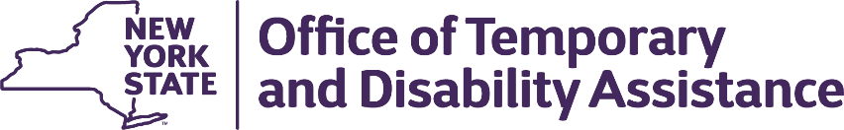 | Kathy Hochul  Governor  Barbara C. Guinn  Commissioner  RAJNI CHAWLA  Executive Deputy Commissioner

WMS – CNS Coordinator Guidance

Section 1
Guidance Topic: COVID Unwind Lapse Prevention and Chafee
Date: October 8, 2024
To: Subscribers
Issuing Division/Office: Upstate Systems Bureau (USB)
Employment and Income Support Programs (EISP)
Effective Date: October 25, 2024
Suggested Distribution: Commissioners, TA and SNAP Directors, HEAP Coordinators, WMS Coordinators and BICS Coordinators
Contact Information: DOH Local District Support Unit (518) 474-8887

Section 2
Chafee WINR4008 Report – Updated Report Timing

This change is being implemented October 2024. The process had previously run using the following logic:
The initial pull of clients that qualify for the automated renewal are selected during the WINR4133 process the first full weekend of the month. The 3rd weekend of the month, CNS picks up the file and sends notices. At the same time, WMS creates the WINR4007 CHAFEE RECERT REPORT (note: the report is not tied to whether or not CNS created the renewal notices) based on the file generated by the WINR4133 process. This file is then held until the weekend prior to the Auth To date and is then used to create the renewal transactions, and produce the WINR4008.

Ex:
- WINR4133 run 1/7/17 and creates the file for auth to dates in March
- CNS picks up file and sends renewal notices weekend of 1/21/17
- WMS creates WINR4007 on 1/22/17
- WMS creates WINR4008 and renewal transactions weekend of 3/25/17

Transaction reason code for Chafee renewal is 863 and Auth # ends with MA2.

The WINR4008 scheduling has changed from running on the weekend prior to the Auth To date, to run on the 25th of each month. This will run prior to the COVID Unwind Lapse Prevention.

COVID Unwind Lapse Prevention WINR4164 and WINR4165 – Updated Report Timing
This is a change from the notification given in Coordinator Letter 23.3 sent October 19, 2023. This change is being implemented October 2024. It had previously run on the last Sunday of each month that is not the last day of the month (if Sunday is the last day of the month, run previous Sunday). This scheduling has changed, to run on the 25th of each month.

Two district reports will be produced in PHRED:
- An eligibles report will list MA cases that received a successful extension: Report ID (WINR4164), and Report Title “COVID Unwind Lapse Prevention Eligible Cases.”
- An exception report will list MA cases that could not be extended because of a pending transaction. Report ID (WINR4165), Title “COVID Unwind Lapse Prevention Exceptions.”

