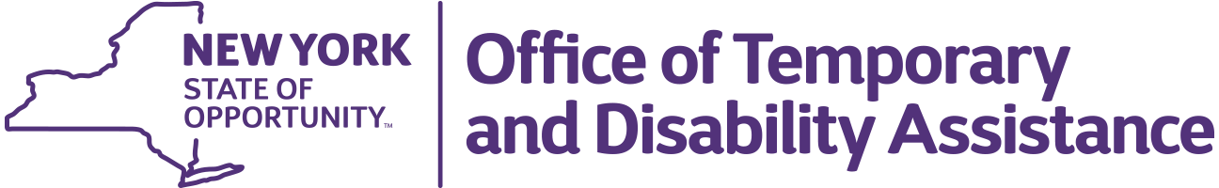
Kathy Hochul
Governor

BARBARA C. GUINN
Commissioner

WMS – CNS Coordinator Guidance

Section 1
Guidance Topic: Release 24.2 – Explanation of WMS/CNS Enhancements Effective June 16, 2024
Date: May 20, 2024
To: Subscribers
Issuing Division/Office: Upstate Systems Bureau (USB)
Employment and Income Support Programs (EISP)
Effective Date: June 16, 2024
Suggested Distribution: Commissioners, TA and SNAP Directors, HEAP Coordinators, WMS Coordinators and BICS Coordinators
Contact Information: General WMS questions: otda.sm.eisp_upstatesystems@otda.ny.gov
Sections (3 – 10): DOH Local District Support Unit (518) 473 – 6397

Section 2 - Purpose
The purpose of this guidance is to provide local social services districts (districts) with an explanation of the WMS/CNS enhancements that are scheduled to become operational on the Production System on June 16, 2024, unless otherwise noted.

Section 3 – Application of 12 Months Post-Partum to Separate Determination Cases

Pregnant Consumers on case types 11, 12, 16, and 17 who are found ineligible for Temporary Assistance but still eligible for MA coverage will be entitled to 12 Months Post-Partum coverage. During the MA case opening in the Separate Determination process, AFA code 223 and a 12-month post-partum coverage period will be applied to the pregnant consumer. For individuals already in their post-partum coverage period, the Coverage To date will be calculated to continue their 12 months PP coverage.

Section 4 - County-to-County Transfer Processing Changes for QI Cases

The county-to-county transfer (Luberto) process has been modified to use standard logic when setting Authorization and Coverage Dates for QI cases where the MSP Indicator = U. From Dates on the new district’s case will be set to one day after the old district’s closing MA Coverage To Date. To Dates on the new district’s case will be set to either four months in the future or one year from the old district’s closing Authorization From Date, whichever is greater.

Section 5 - Newborn Processing Changes for Incarcerated, OMH and MCTP Individuals

The WMS newborn process will be modified to open a new MA case for the newborn when the birthing individual is incarcerated, or part of the Office of Mental Health (OMH) or Medicaid Cancer Treatment Program (MCTP) populations. If the birthing individual’s Coverage Code is 25 or 26, or the district is 99, a new WMS Case Type 20 will be opened for the newborn following standard newborn process procedures, which include using the newborn demographics and address from the hospital. If the district is 99, the new case will be opened in the district matching the address from the hospital.

Birthing individuals meeting this criteria will receive an alert code of 03. The description of this code will be updated from ‘Mother on SSI’ to ‘Mother on SSI, MCTP, OMH or PRSNR’. They will also receive the alert ‘12 PP MCTP/OMH/PRSNR MOTHER’ on the WINR5230 report, defined in Section 6 of the WMS Coordinator Letter dated October 17th, 2023.

Section 6 - MIPPA LIS Report

A report of individuals who applied for the Low Income Subsidy program through SSA as part of the Medicare Improvements for Patients and Providers Act (MIPPA) will be delivered daily to districts using PHRED. This will replace the MIPPA process where files were delivered to LIMIP folders for each district. Additional details will be provided as they become available.

Section 7 - Delete Recertification Source Code 1

This one-time process is being deployed to delete Recertification Source Code 1 from all Medicaid cases with Case Type 20 and Recertification Source Code equal to 1 to allow them to go through the Aged, Blind, Disabled auto-renewal process.

Section 8 - Report of Medicaid Applications Over 45 Days

A new report, WINM1240, for Medicaid-only cases is being created to mirror the WINR 1240 App Reg Processing Report, but will provide data over a 45-day period instead of the 30-day reporting window used for the WINR 1240 report. The report will be available on PHRED for districts and state staff.

Section 9 - Update FPLs on S0033 and E0019
Updates made to the FPL levels and dates that are hardcoded in Paragraph S0033 and Elixir E0019 to match the 2024 levels.

Section 10 - Revise CNS TT1 to Include Supplement A
Due to an issue with forms in 2014, WMS CNS Reason Code TT1 language directed to individuals who mistakenly applied to NY State of Health was revised to eliminate reference to Supplement A and remove it as an insert with the notice. This has created an increased workload for districts. To lessen the workload, the notice language will reference the Supplement A and the form will be included with the notice.

